**Secure OR Schematic**

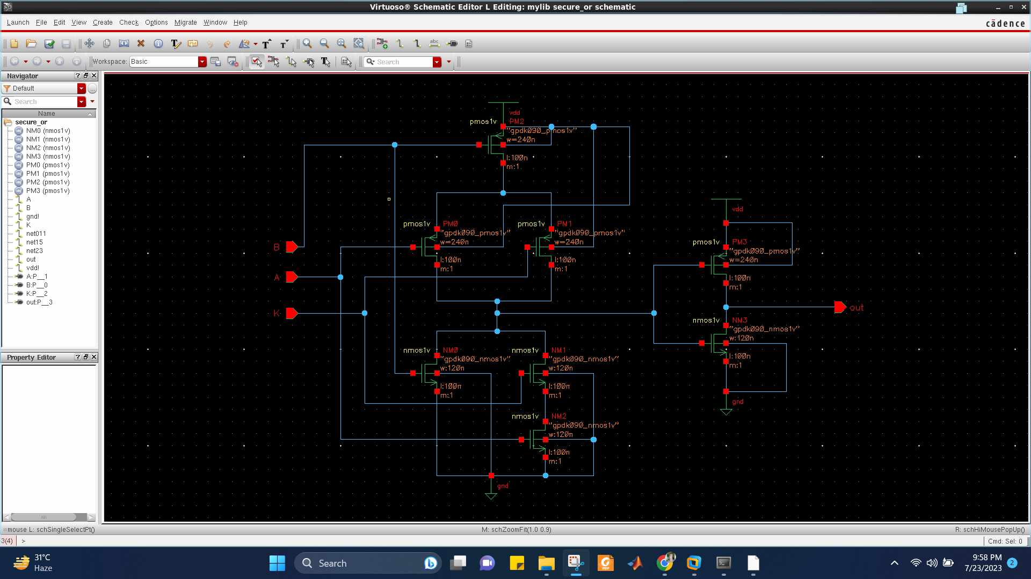

**Secure OR Waveform**

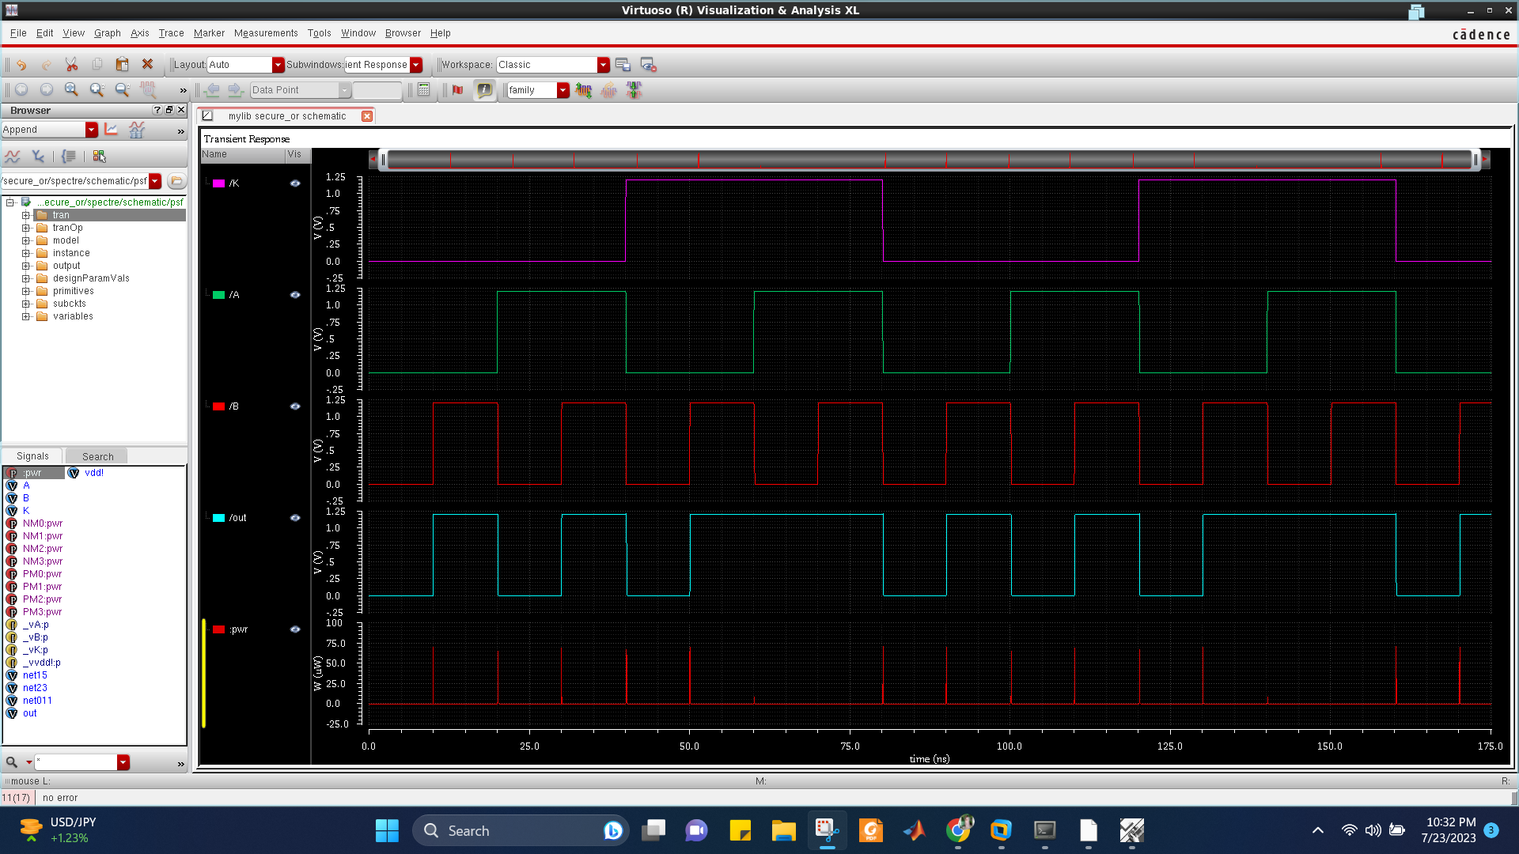

**Secure OR Propagation Delay**

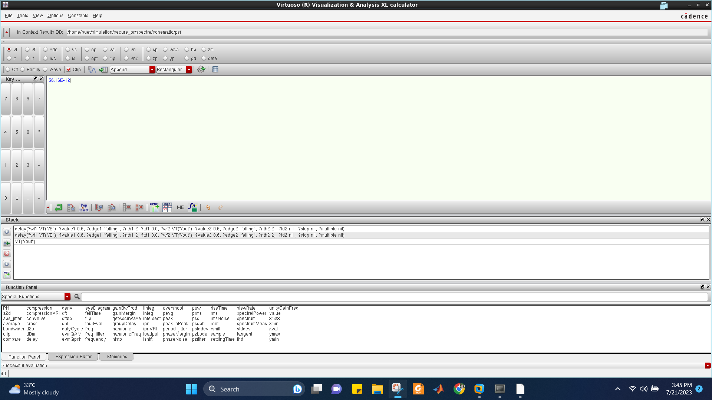

**Secure OR Average Power**

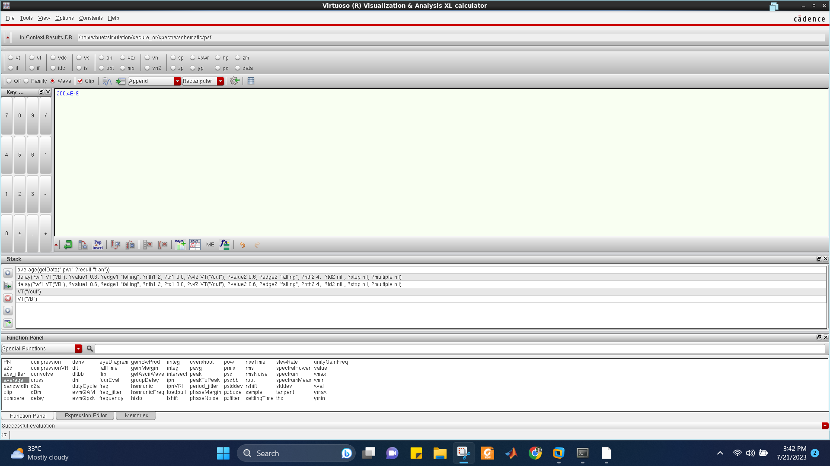

**Secure OR Layout DRC**

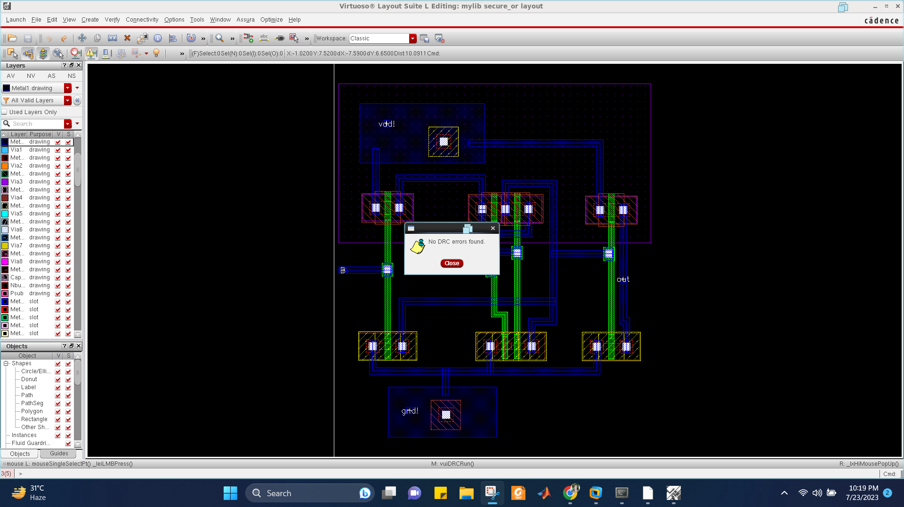

**Secure OR Layout LVS**

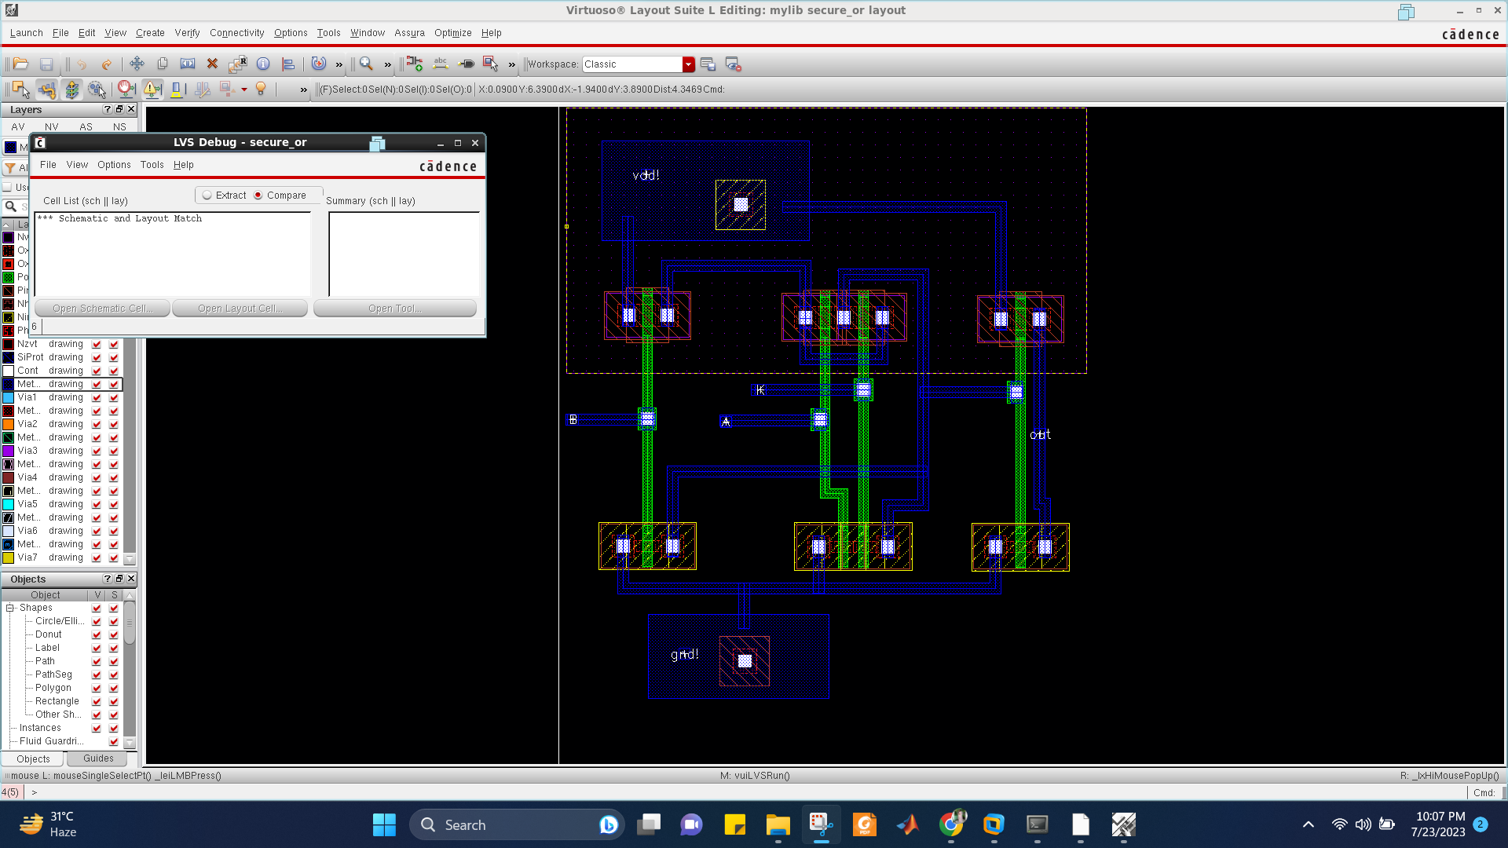

**Secure AND Schematic**

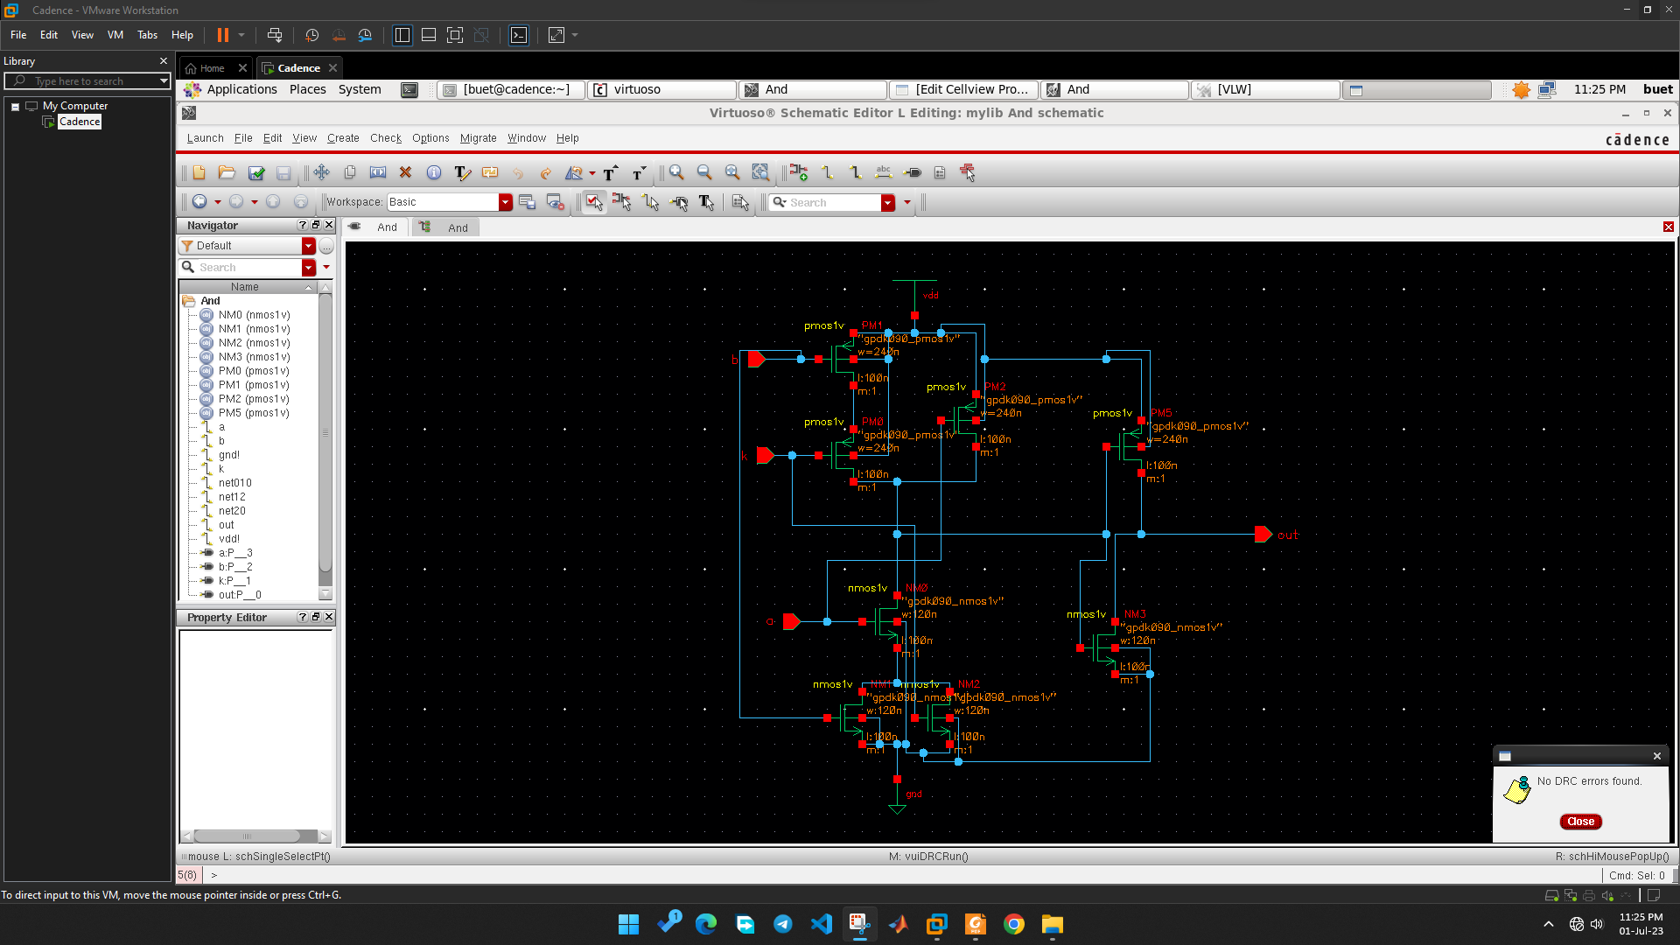

**Secure AND Waveform**

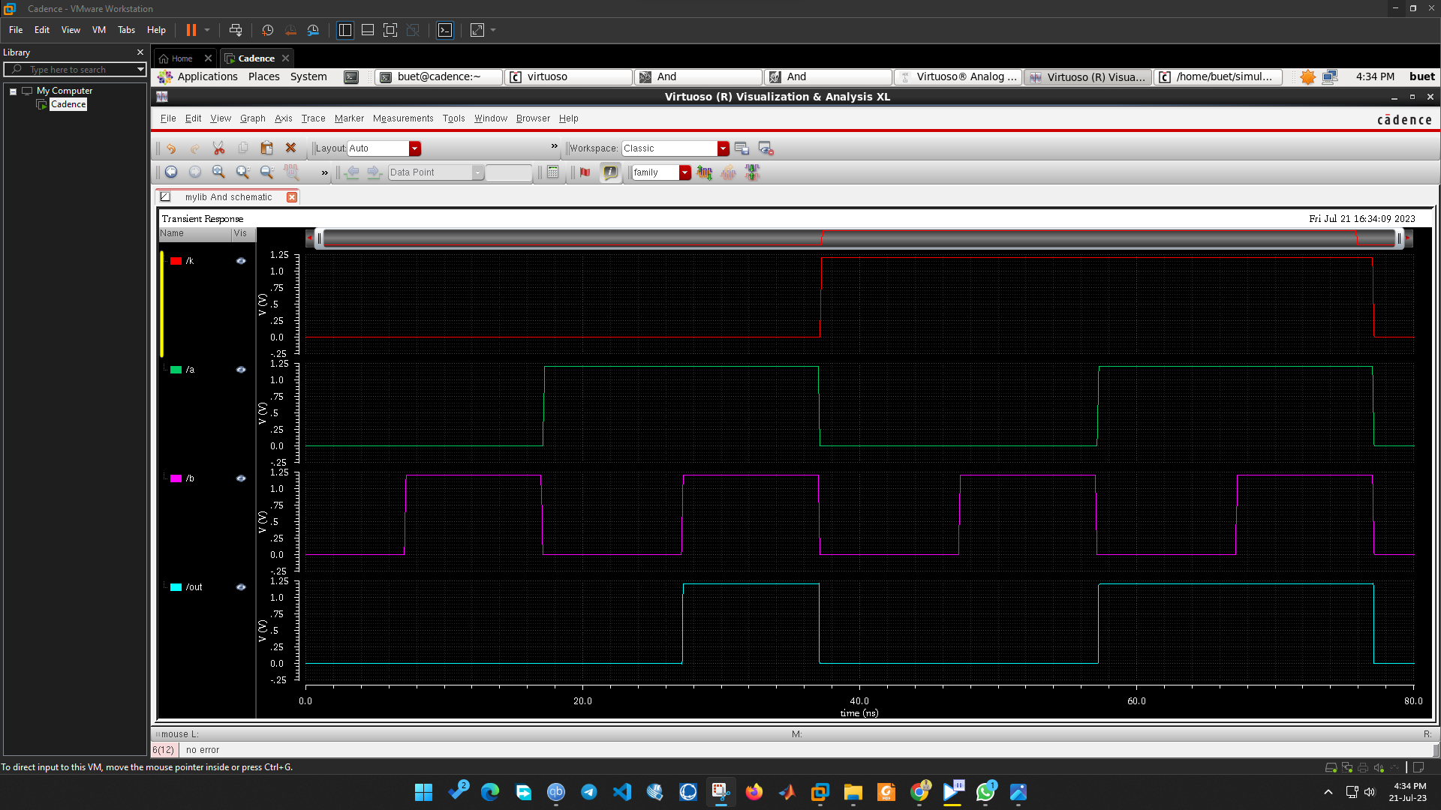

**Secure AND Propagation Delay**

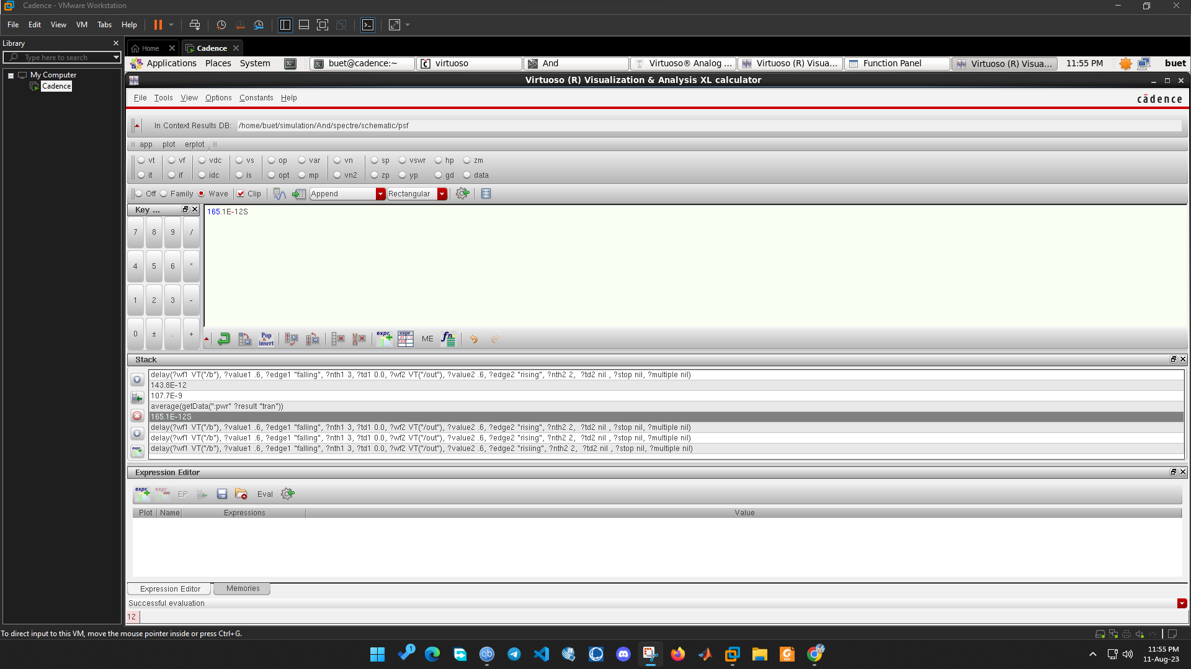

**Secure AND Average Power**

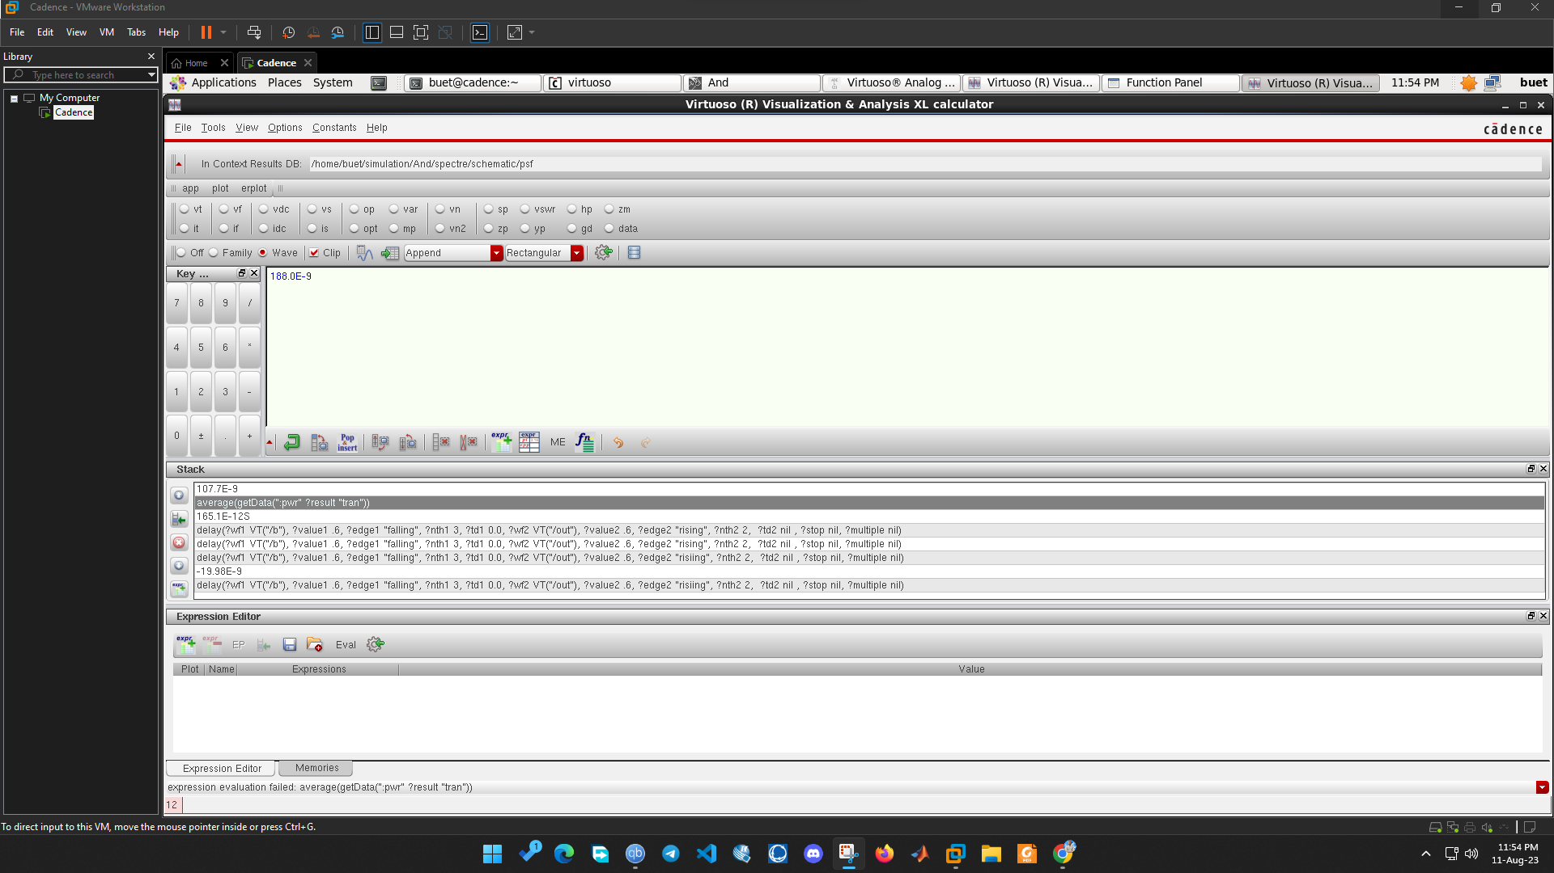

**Secure AND Layout DRC**

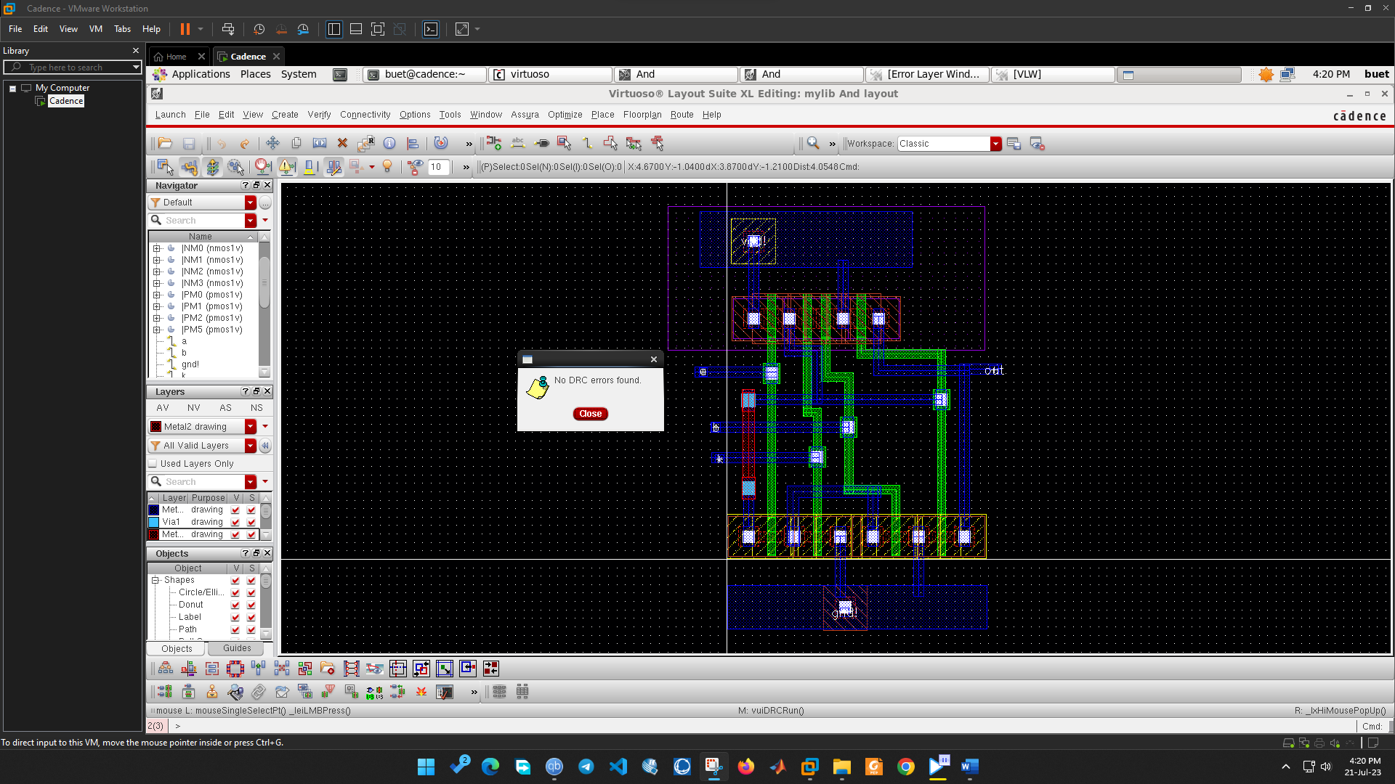

**Secure AND Layout LVS**

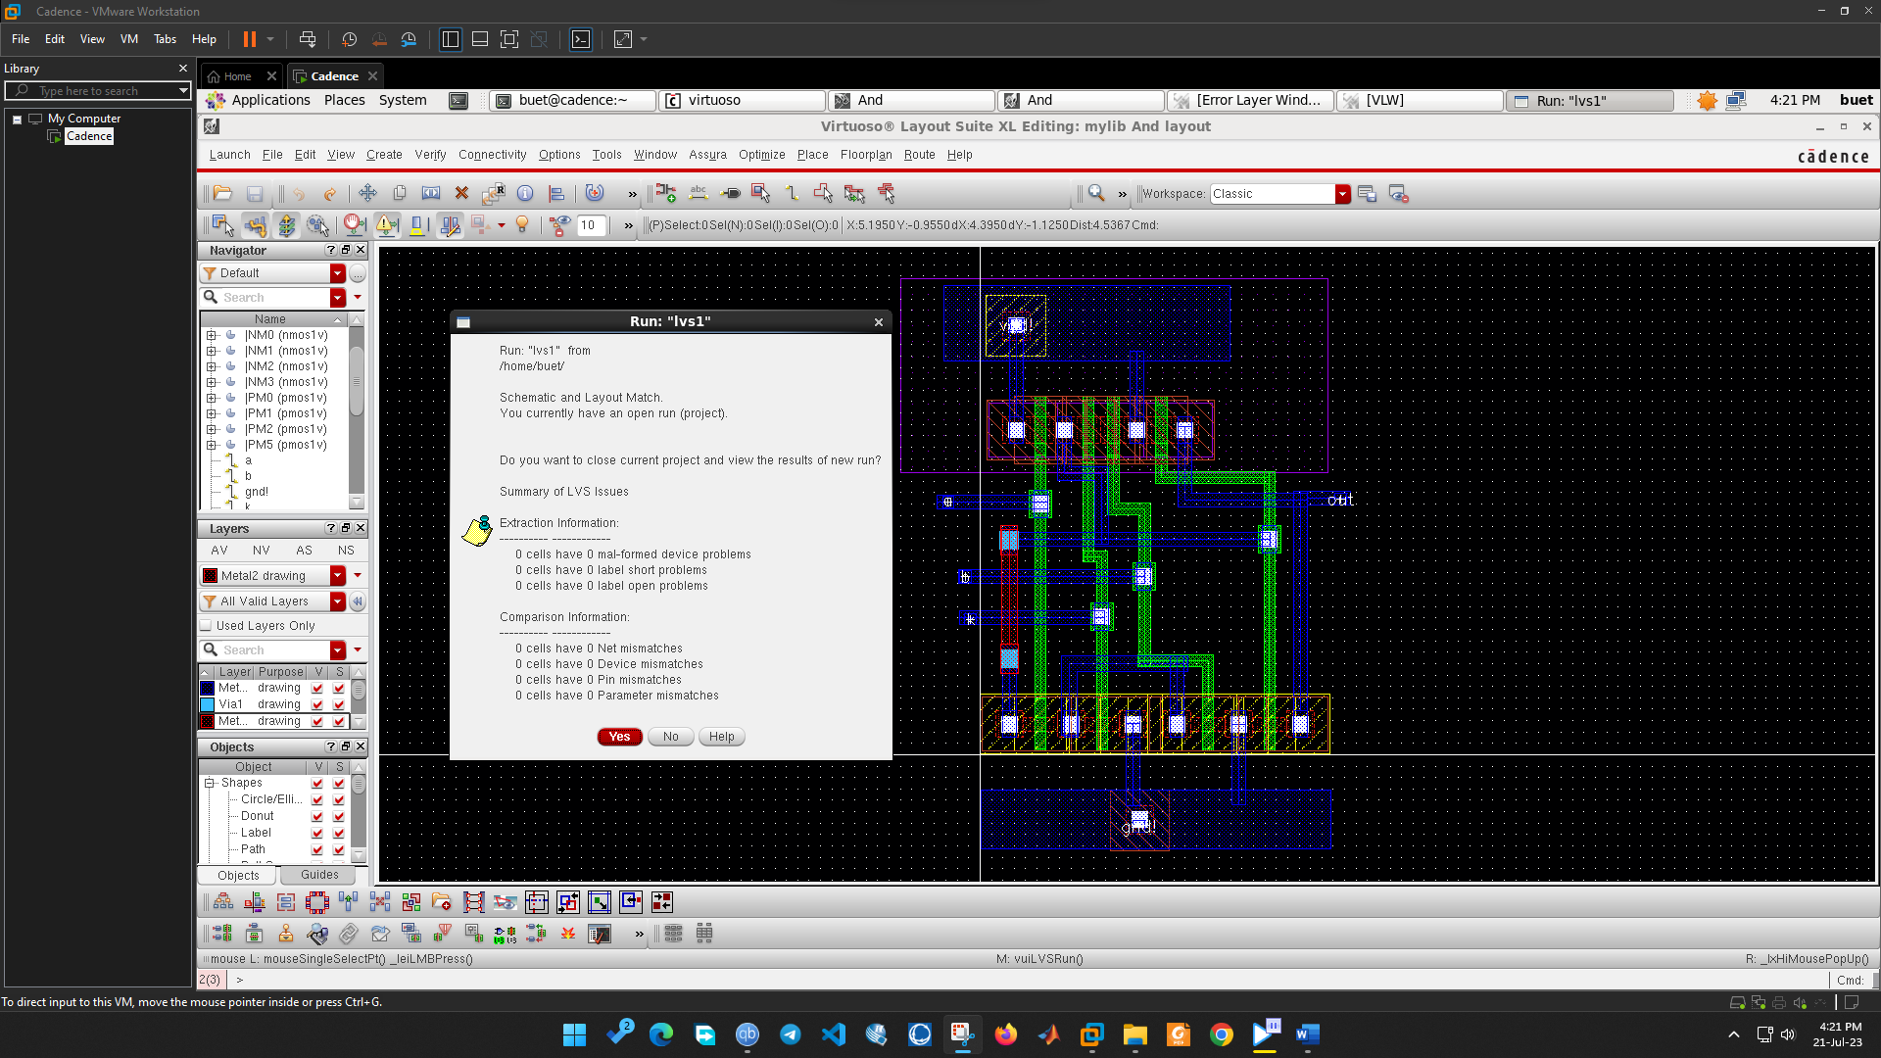

**Secure NOR Schematic**

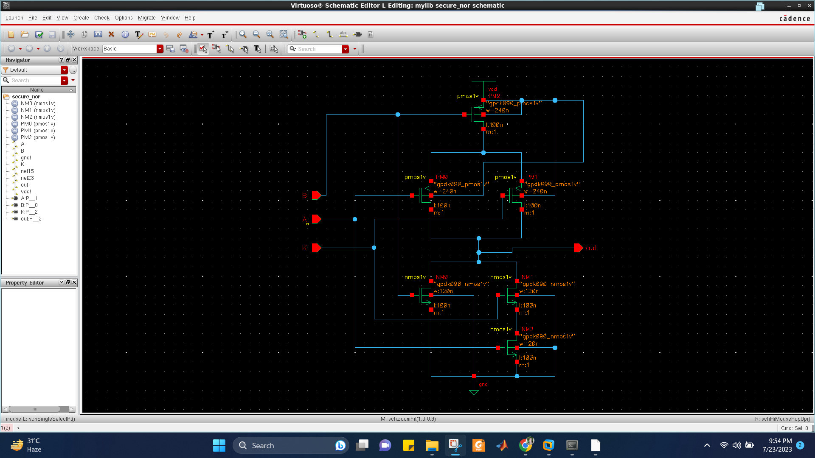

**Secure NOR Waveform**

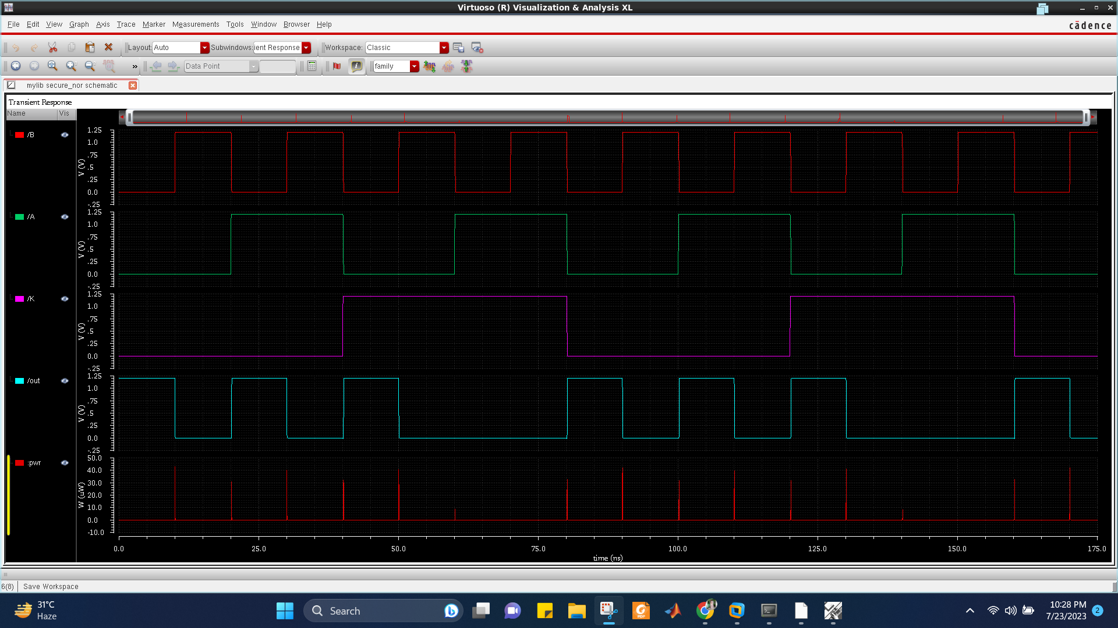

**Secure NOR Propagation Delay**

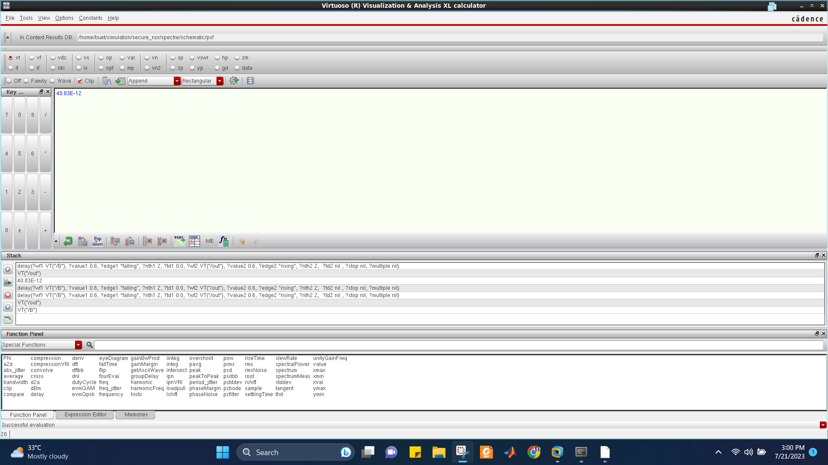

**Secure NOR Average Power**

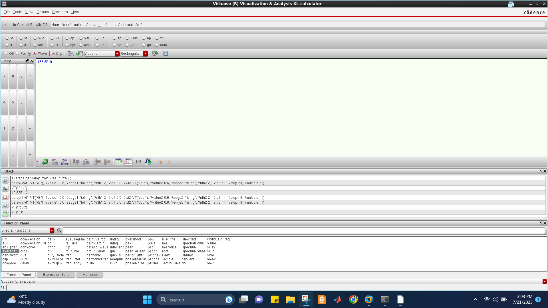

**Secure NOR Layout DRC**

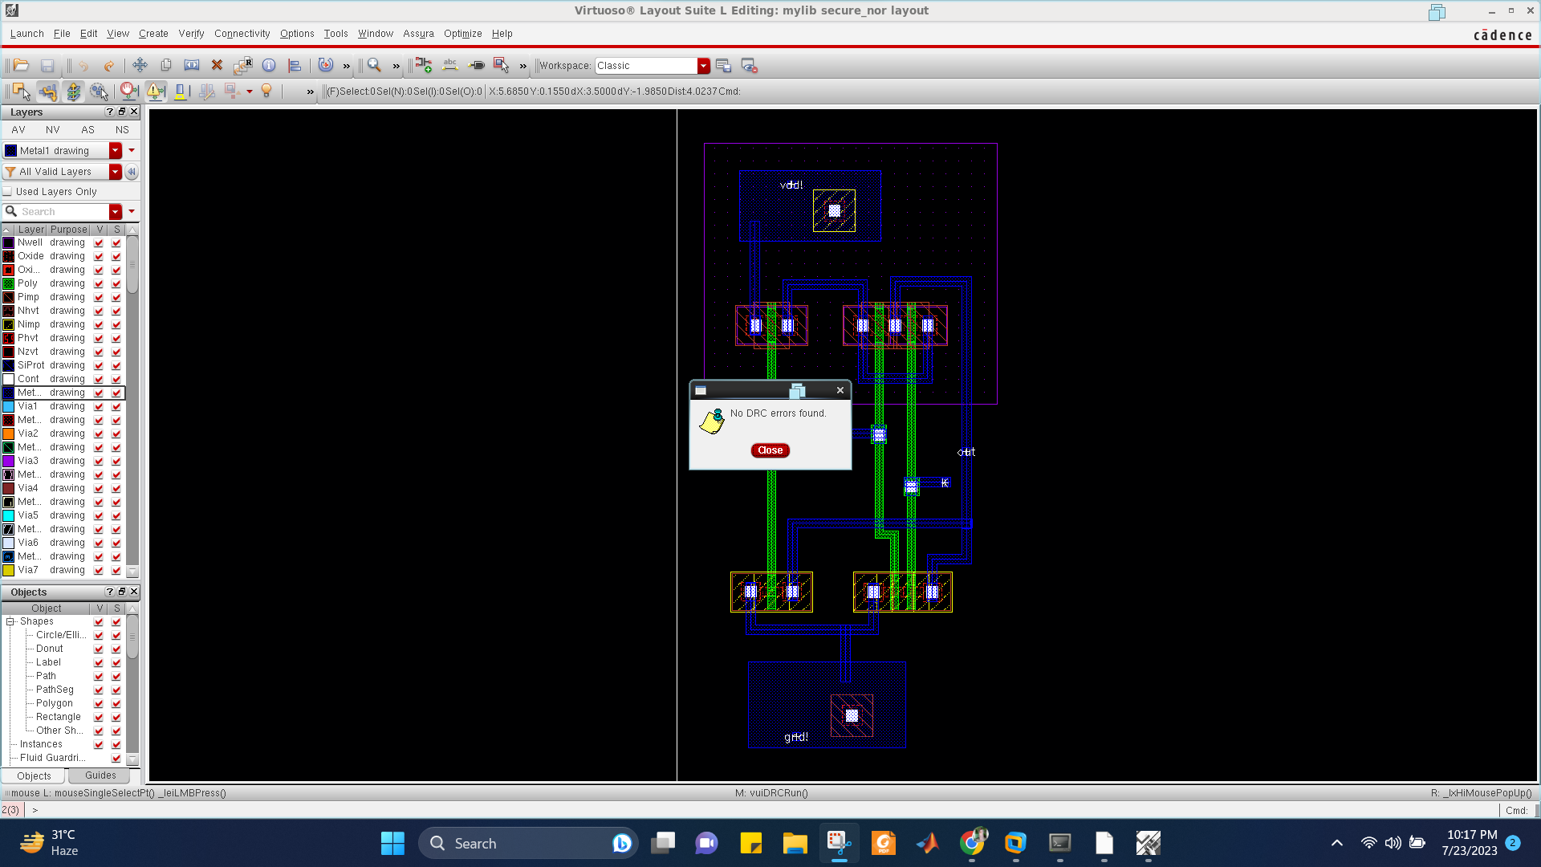

**Secure NOR Layout LVS**

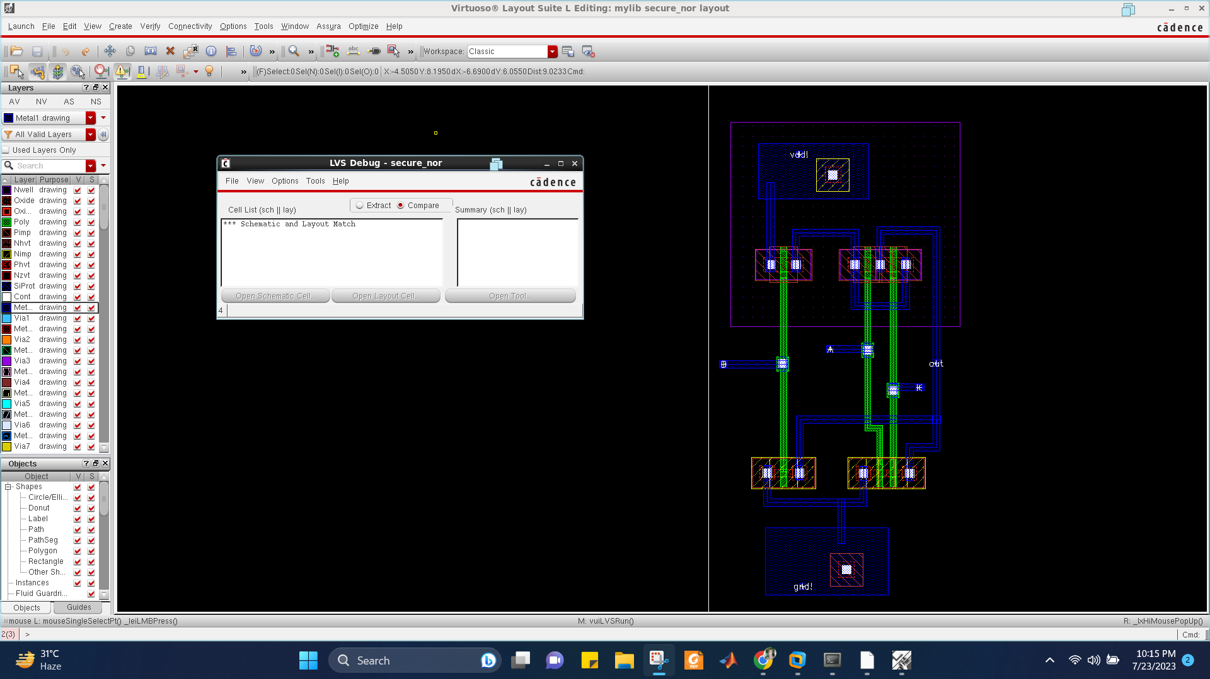

**Secure NAND Schematic**

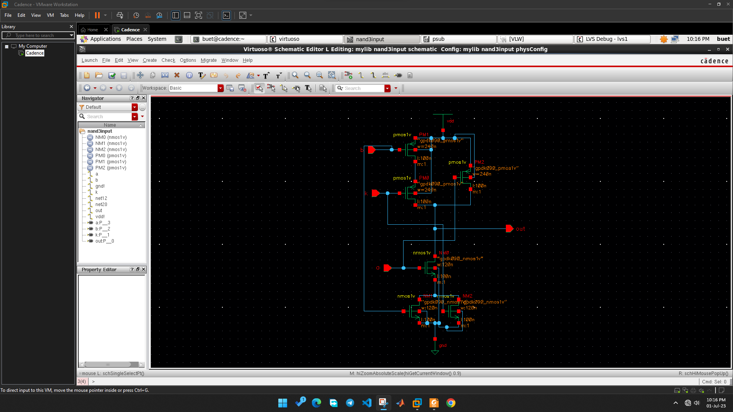

**Secure NAND Waveform**

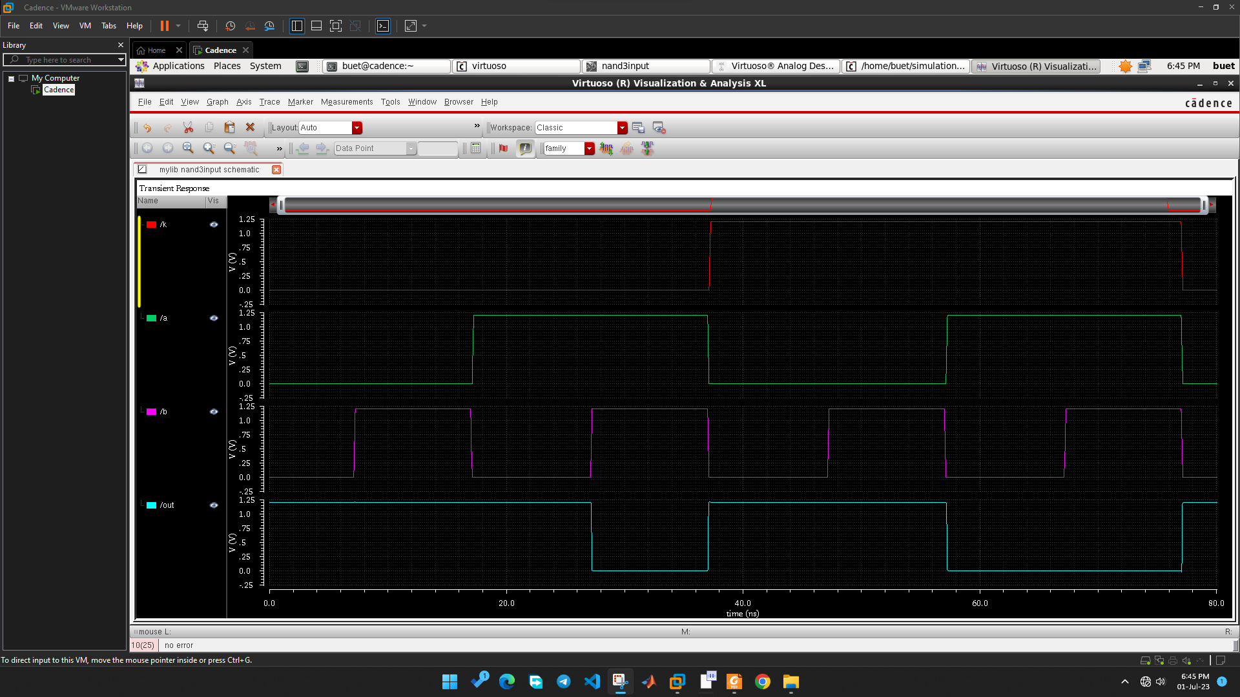

**Secure NAND Propagation Delay**

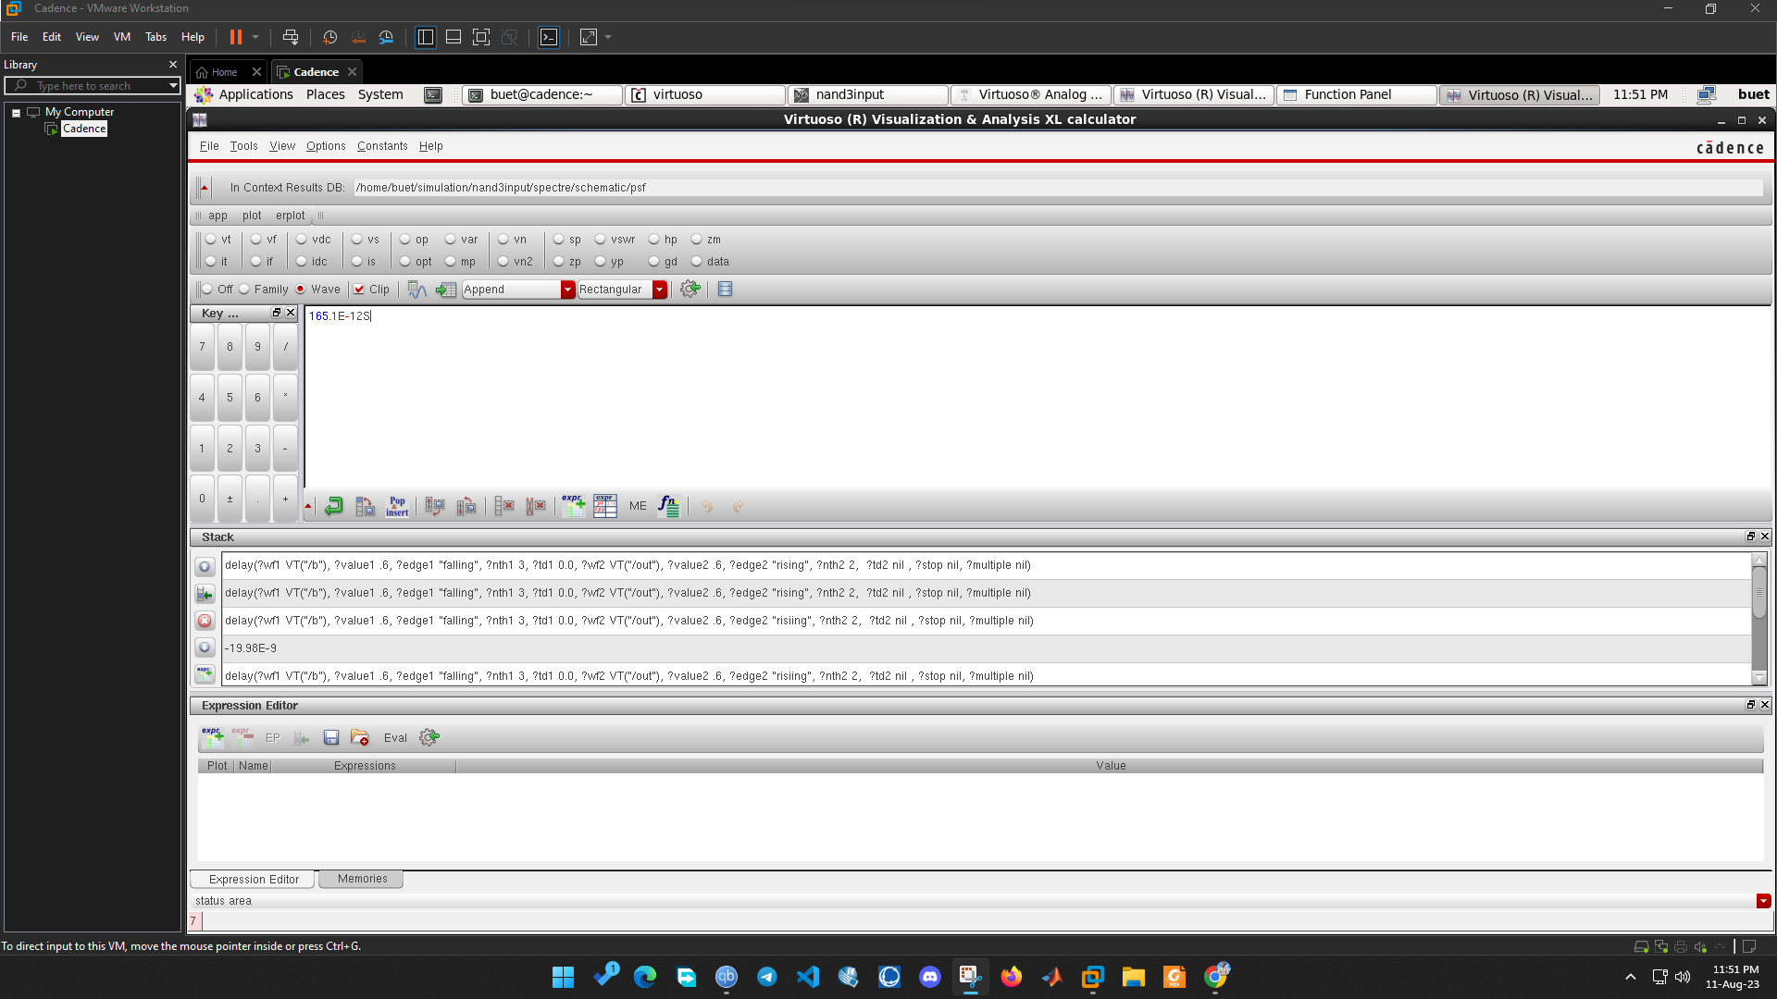

**Secure NAND Average Power**

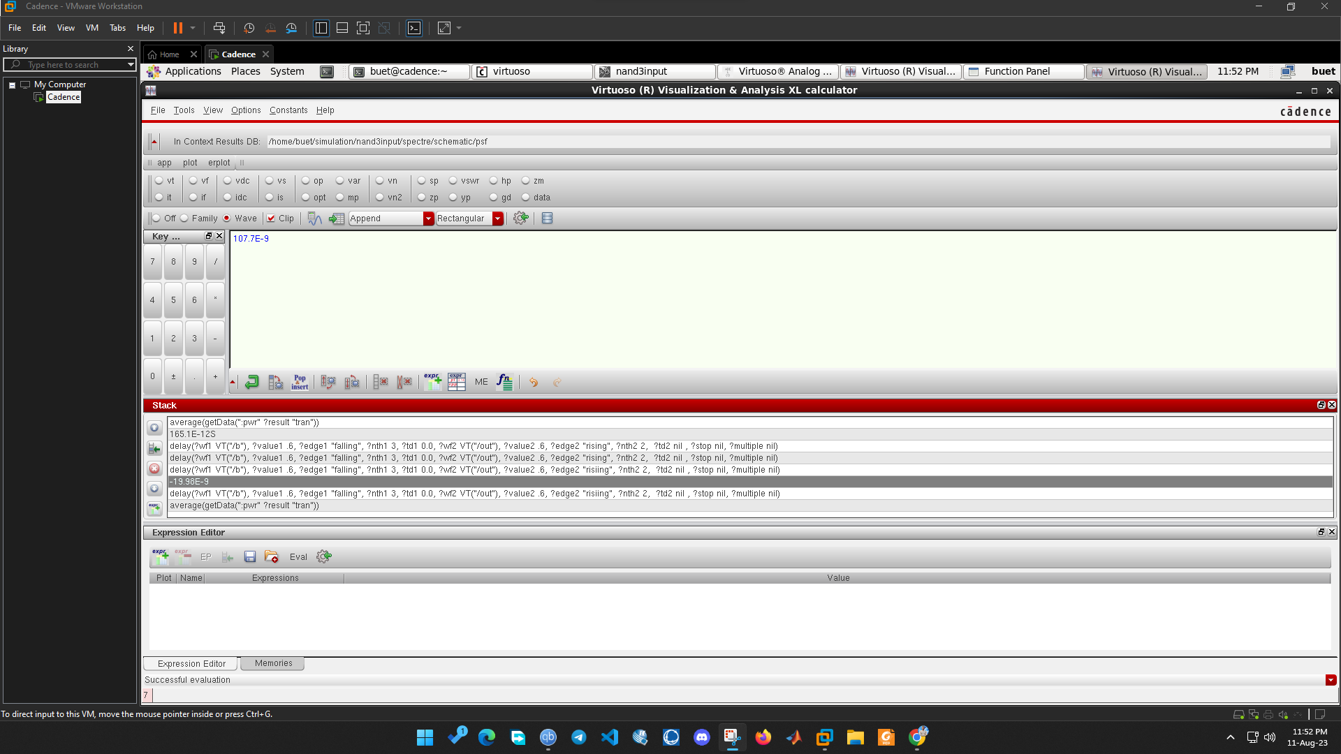

**Secure NAND Layout DRC**

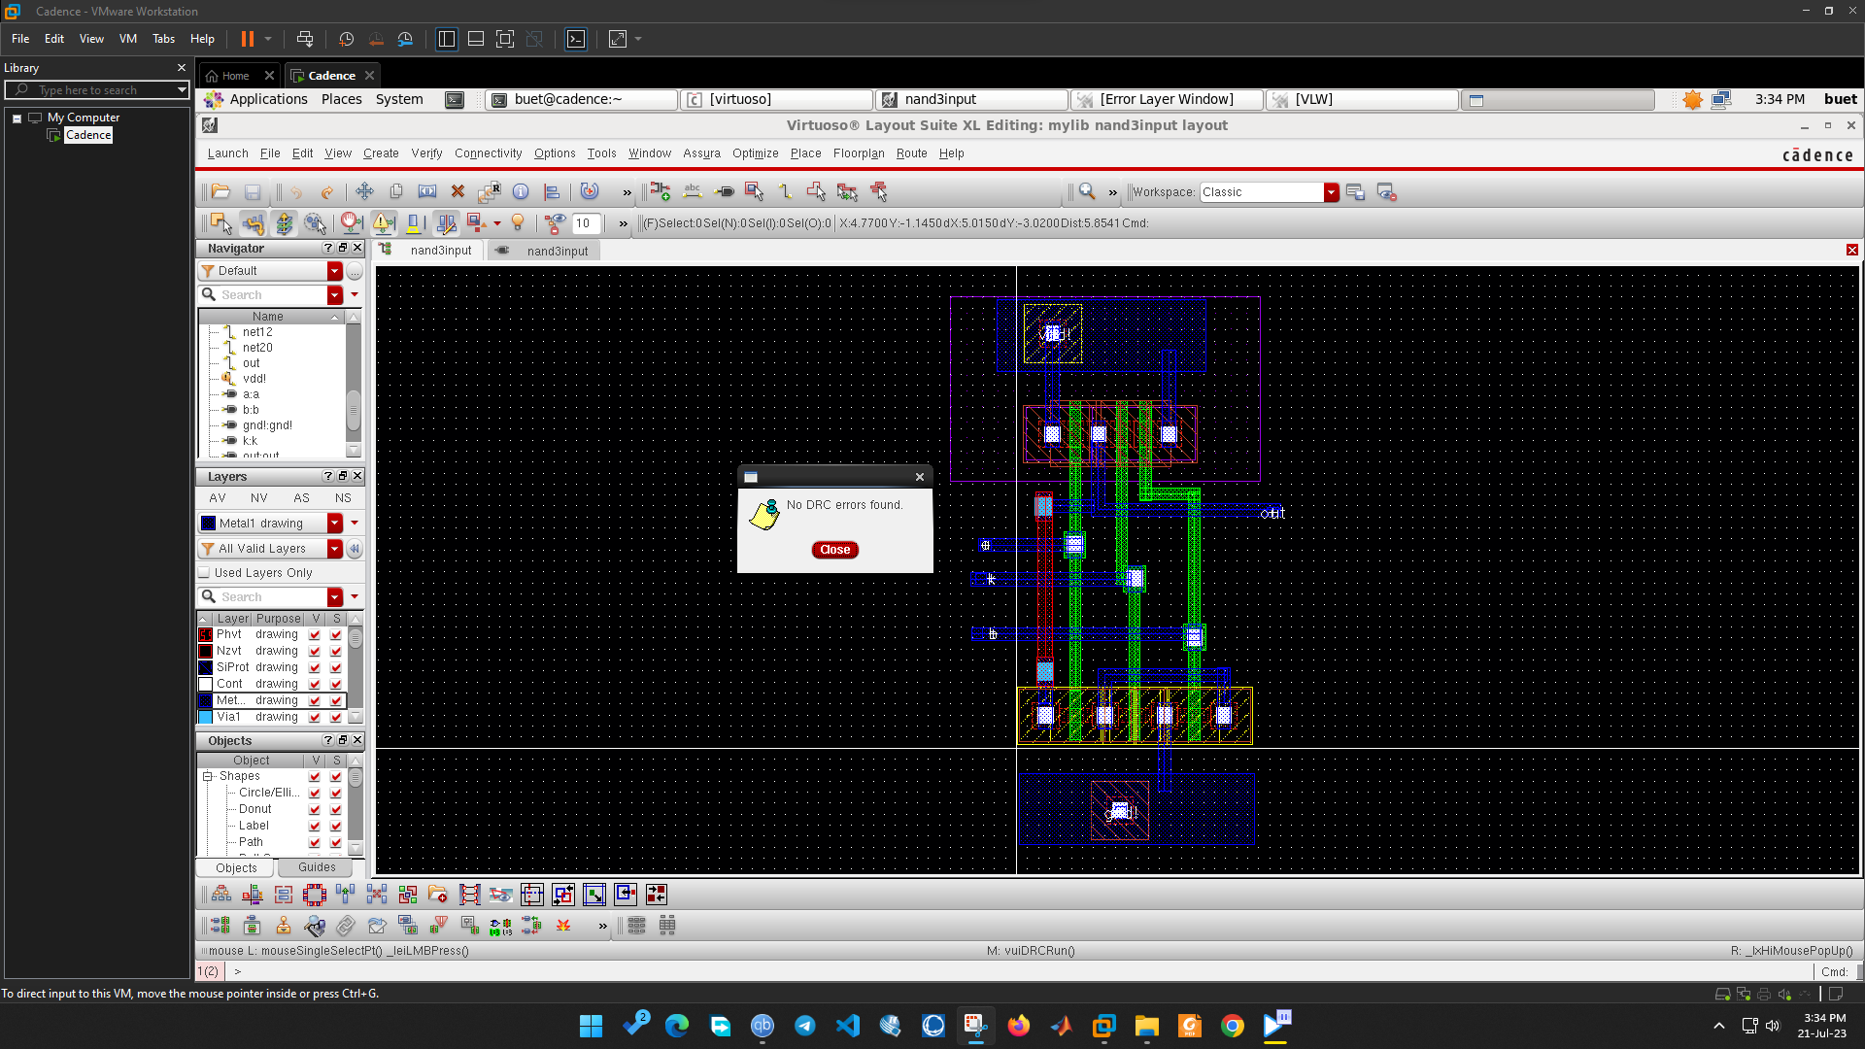

**Secure NAND Layout LVS**

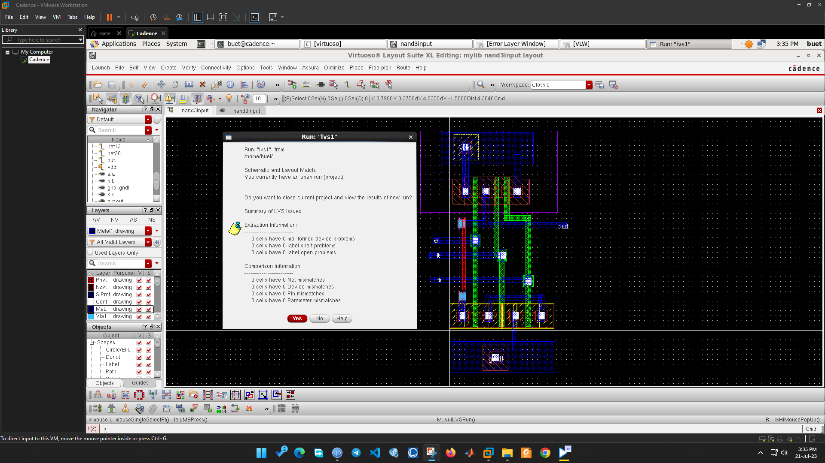

**Secure XOR Schematic**

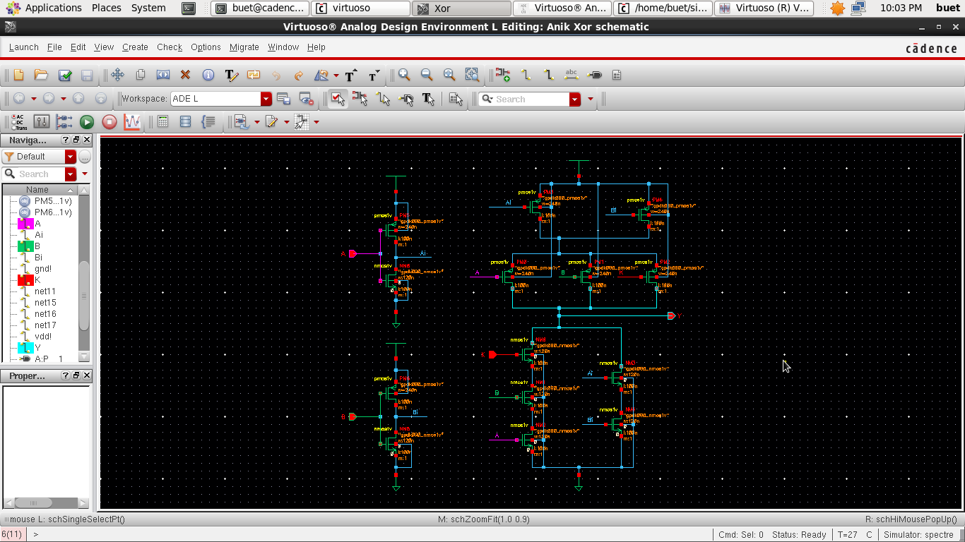

**Secure XOR Waveform**

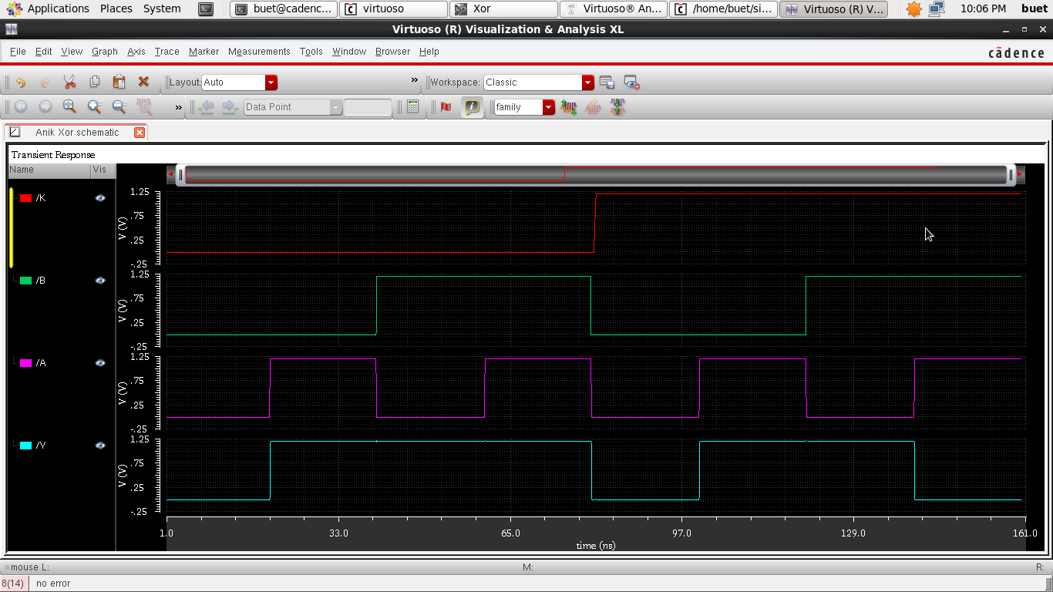

**Secure XOR Propagation Delay**

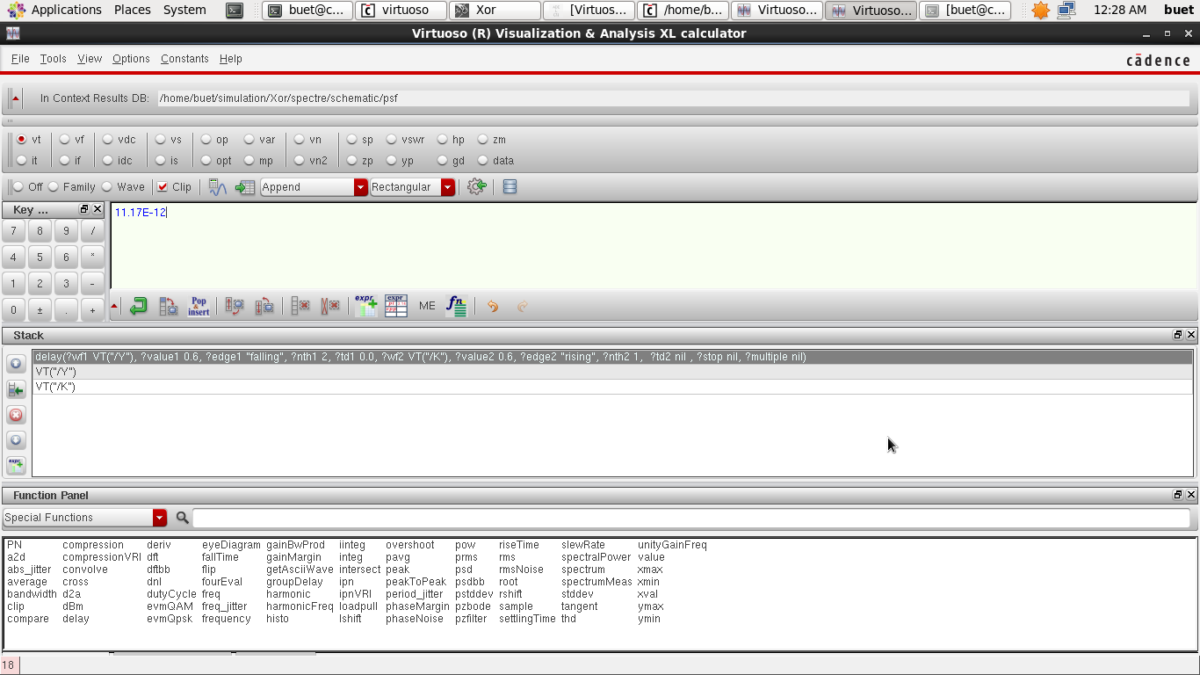

**Secure XOR Average Power**

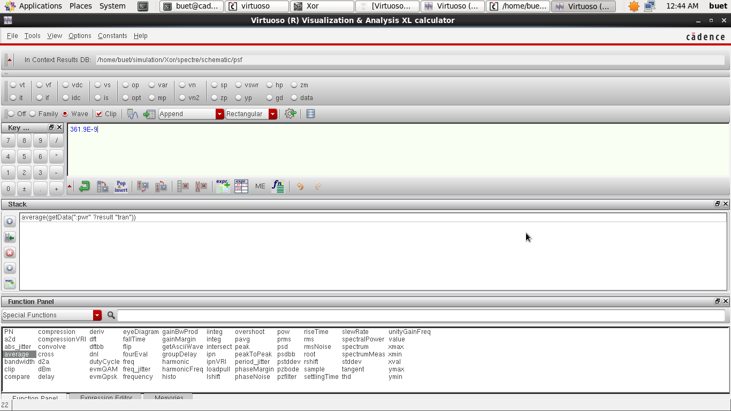

**Secure XOR Layout DRC**

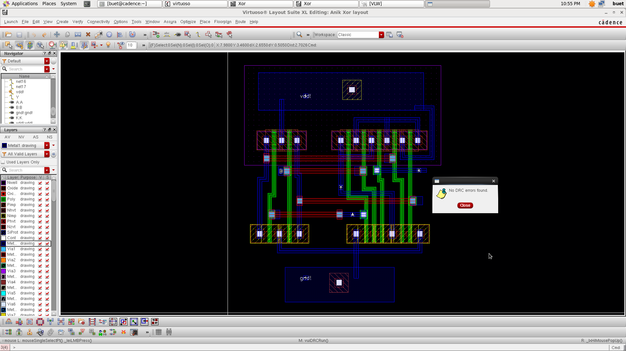

**Secure XOR Layout LVS**

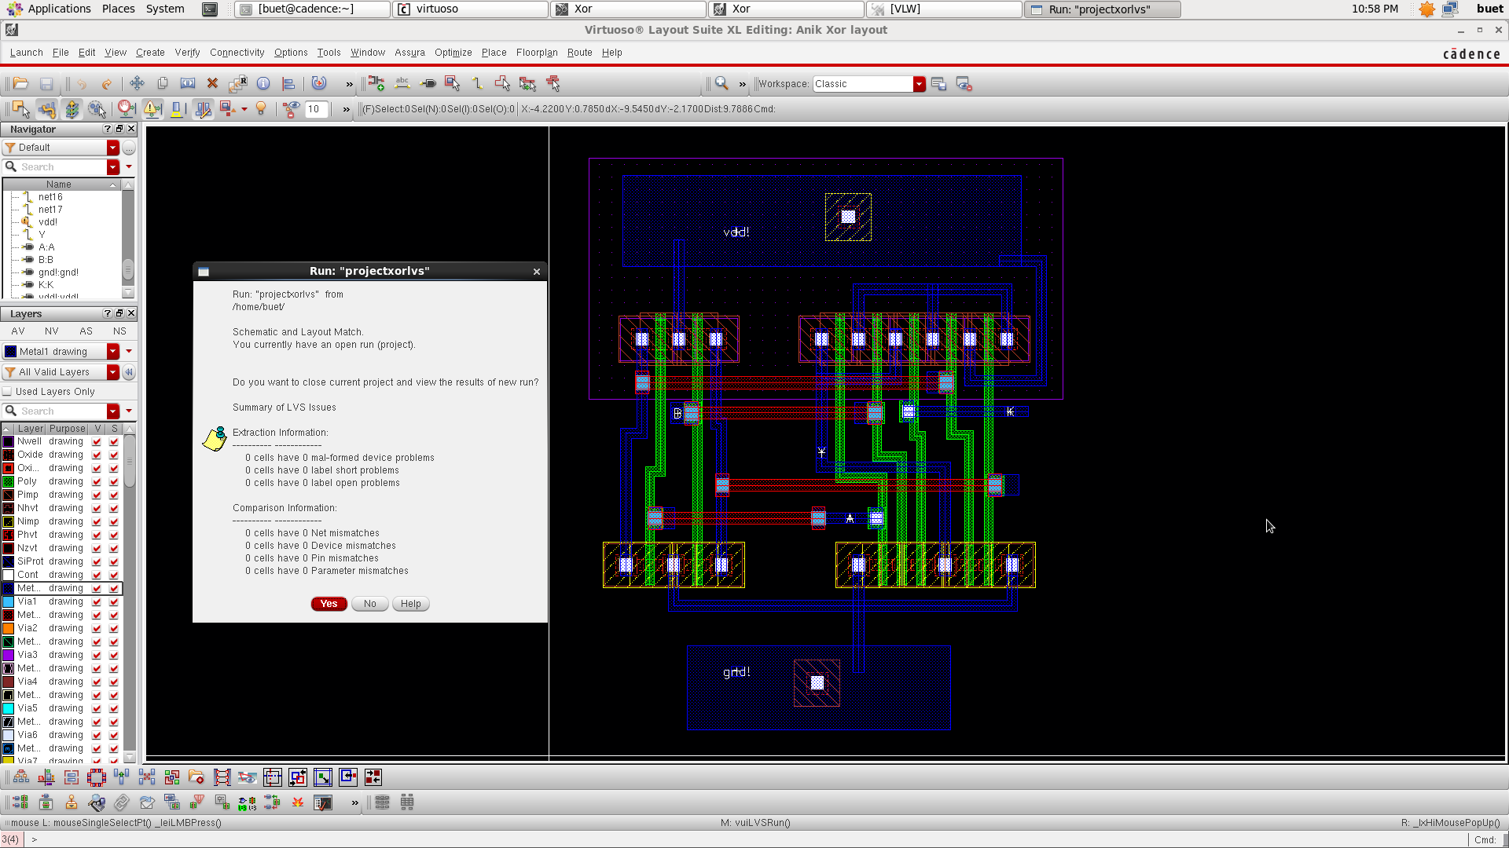

**Secure XNOR Schematic**

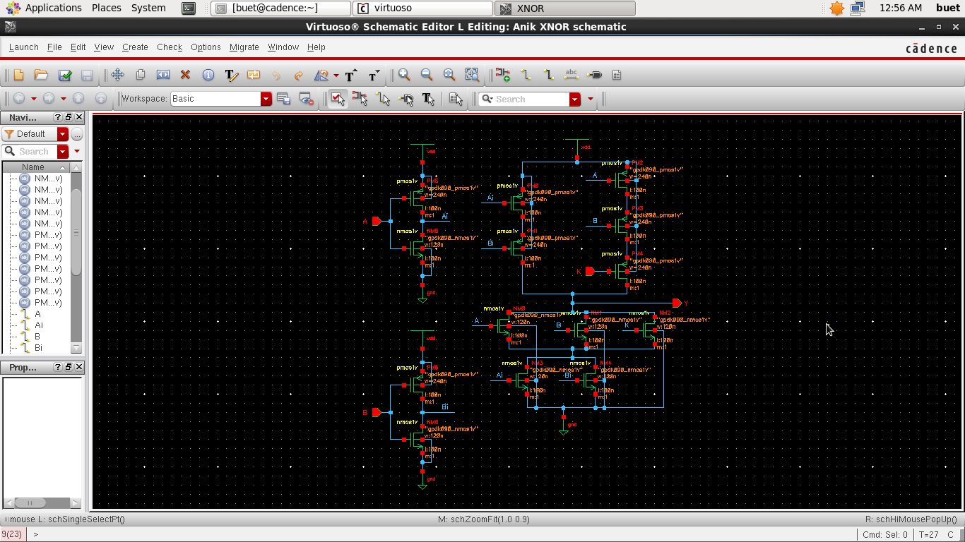

**Secure XNOR Waveform**

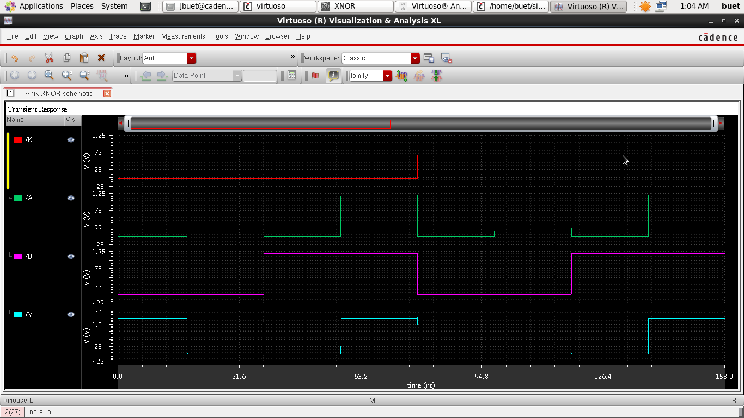

**Secure XNOR Propagation Delay**

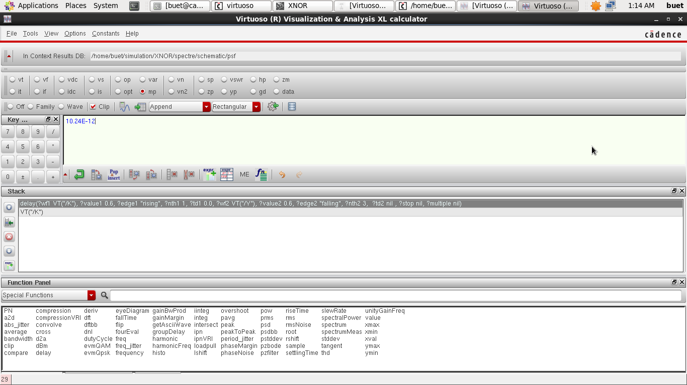

**Secure XNOR Average Power**

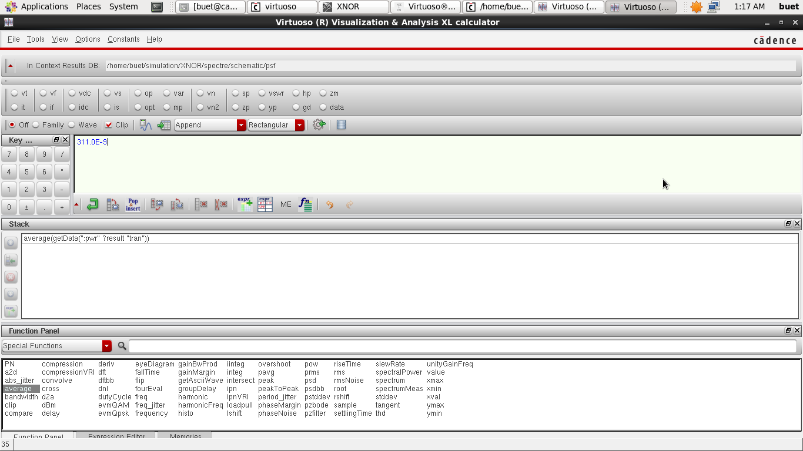

**Secure XNOR Layout DRC**

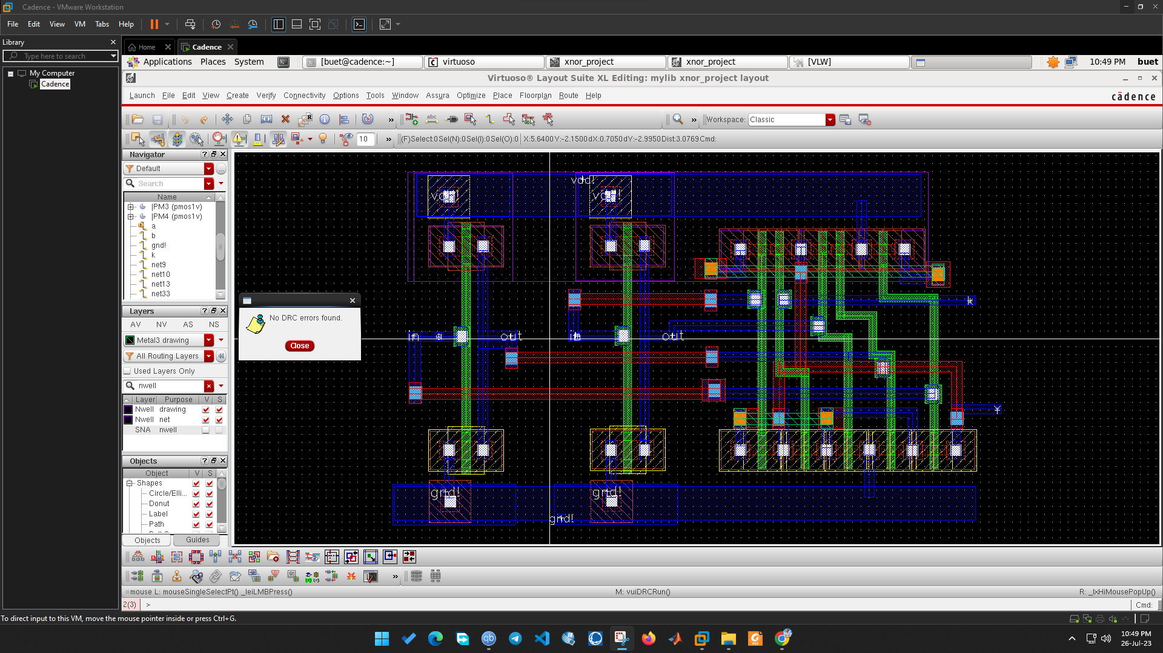

**Secure XNOR Layout LVS**

